Onboarding and setup
Client Name

About you

What products / services do you provide?
What do your customers know you as?
How will you measure success?
How will we know we’ve succeeded? E.g.
- Debtor Days reduced by 30%
- 90+ debtors under control within 2 months
- Not spending time chasing debtors

Key contacts / people of note
- Who is our primary contact?
- Who will respond to queries resulting from our calls?
- Who should be notified of stop work / stop supply?
- Do account managers or sales people need to be involved at all?

Name | Role | Responsibilities

About your customers
Having a good understanding of your customers helps us design the perfect collections process that gets you paid and keeps customers happy.

B2B or B2C?
Where are your customers located?
Business size (SME or Enterprise)
Do they have an accounts payable dept?
Purchase order required?
Relationship level:
- High touch e.g. account manager
- Low touch / transactional
Relative power
What happens if you stop work or supply? How reliant are they on your product / service?
Why do people pay late?
Are there any customers that should NOT be reminded by Debtor Daddy?

About your invoicing process
Having a good understanding of your invoicing and payment processes helps us tailor your workflows and reminders to suit.

How often do you create / send invoices?
E.g. Daily / weekly / once a month on the 30th
What payment terms do you offer?
E.g. 7 days, 14 days, 20th of following
What payment methods do you offer?
E.g. credit card (Stripe), Direct debit, Bank transfer
How often are payments reconciled to invoices?
This will determine the days and times that reminders can be sent out.
Can we resend invoices?
Does the invoice in your accounting system match the invoice your customer originally received?
Do you offer payment arrangements to customers who are in arrears?
Yes or no
Do you have rules for acceptable payment arrangements?
E.g. arrears must be settled within 4 months
How do you keep track of payment arrangements?

Your collections process
Describe how the collections process should work, at a high level. We’ll get into greater detail later on. You can follow a different process for different groups of customers.

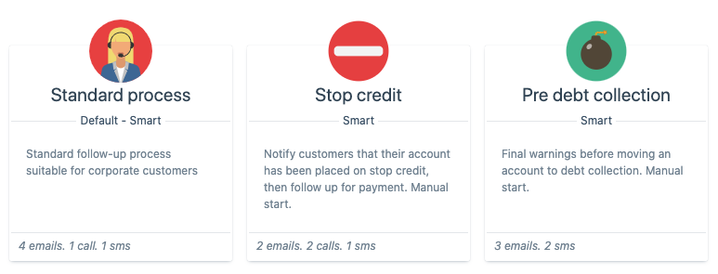

Rename the groups to suit your needs. You can have more than three if you need to. | Group 1  E.g. Small business | Group 2  E.g. Enterprise | Group 3  E.g. Resellers
Should customers be sent a statement before the due date?
This is helpful for larger customers who require purchase orders and have an Accounts Payable team.
When should the first reminder be sent?
E.g. 5 days past due. Or it might depend on each customer’s payment terms or size.
When should the first phone call be made?
E.g. 5 days past due. Or it might depend on each customer’s payment terms or size.
When should accounts be placed on stop credit / on hold?
E.g. when an is 2 months in arrears, no further work will be done.
Who decides whether an account should be placed on hold?
E.g. The account manager or director

For more information about creating your perfect collection process, download this guide.

General setup questions

What name and email address to send reminders from?
E.g. Accounts Team <accounts@yourbiz.com)
What phone number should customers call for accounts enquiries?
This will be included in your reminders.
How would you describe the follow-up process you want?
E.g. fun / casual / friendly vs corporate / professional.
Who will approve sending customers to debt collection?

Call service
Only complete this section if we’re making calls on your behalf.

Call reports should be sent to?
The call report shows the results of our calls for a time period. It can include queries we need you to resolve so we can continue.
What area code should we call from?
We have a range of numbers we call from. Where possible we will use an area code your customers will recognise.
Are there specific days or times we should avoid calling on?
E.g. Don’t call on Mondays OR call in the evenings.

Tasks

Your tasks
Task | Notes | Status
Review and sign off on reminder scripts below
Advise who needs training on the Debtor Daddy software
Introduce your AR Specialist to your team so they’re aware that someone outside the organisation is making calls to customers.

Our tasks
Task | Notes | Status

Reminder scripts
If your client prefers to review and revise reminder scripts in a document, you can copy / paste the reminder text from the Debtor Daddy app below.

Standard process

7 days past due  Method: Email  Template: HTML | Oops - did you forget?  Dear {contact.first_name, fallback="valued customer"},  Our records indicate that we have not yet received payment for the following invoices.  If you have already paid please let us know, otherwise can you please pay the invoice as soon as possible?  Much appreciated.  {my.org_name}  {account.summary}
14 days past due  Method: Email  Template: HTML | Overdue invoices for {my.org_name}  Dear {contact.first_name, fallback="valued customer"},  Our records indicate that after sending a previous reminder, we still have not received payment for the following invoices. Your account is now {account.days_overdue} days overdue.  If you have already paid please let me know, otherwise can you please pay the invoice as soon as possible.  Much appreciated.  {my.org_name}  {account.summary}
15-22 days past due  Method: Call  Tone: Friendly | Your AR Specialist attempts to make contact via phone to find out why payment has not been made.  They will provide details of notes, feedback, expected payment dates, next actions required via the Call Report which you’ll receive by email.
~23 days past due  Method: Email  Template: HTML | URGENT: Overdue invoices for {my.org_name}  Dear {contact.first_name, fallback="valued customer"},  Our records indicate that after sending multiple reminders we still have not yet received payment of {account.total_amount_overdue}. It is now {account.days_overdue} days overdue.  If you have already paid please let me know, otherwise can you please pay the invoice urgently.  Much appreciated.  {my.org_name}  {account.summary}

How you can help us succeed
- Keep your accounts reconciled daily.
- Respond to our queries within 48 hours.
- Keep customer contact details up-to-date in your accounting system.

